**JAVA**

**Java is a robust programming language since it uses strong memory management**. We can also handle exceptions through the Java code. Also, we can use type checking to make our code more secure. It doesn't provide explicit pointers so that the programmer cannot access the memory directly from the code.

## General Java Development Tools

### 1. [JDK (Java Development Kit)](https://java.com/en/download/faq/develop.xml)

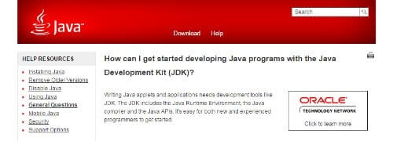

When it comes to developing Java-based applets and applications, a necessary tool is JDK. The JDK includes the Java Runtime Environment, the Java compiler, and the Java APIs. This tool is easy to use both for new and experienced programmers.

**Key Features:**

* Java Runtime Environment
* Java compiler and Java APIs
* Good for beginners and professionals, alike

**Cost:** FREE

### 2. [Gradle](https://gradle.org/" \t "_blank)

[@gradle](https://twitter.com/gradle)

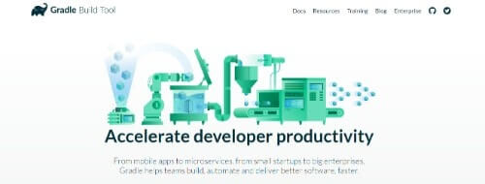

Gradle is a tool that is a combination of almost everything you could need. It can help in developing anything from mobile apps to microservices and is suitable for companies from small startups to big enterprises.

**Key Features:**

* Build anything
* Rich API that can automate everything
* Fast
* First-class support for your IDE of choice.

**Cost:**

* Contact for a quote

### 3. [Apache ANT™](https://ant.apache.org/)

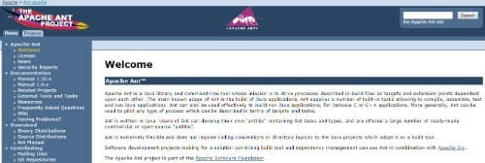

Apache ANT™ is an open source tool by Apache Software Foundation. The tool is very simple, with many features. It is a Java library and command-line tool that aims to drive processes.

**Key Features:**

* Simple
* Automate tasks
* Java library, command-line tool
* Built-in tasks that allow you to compile, assemble, test and run Java applications
* Can be used to pilot any type of process

**Cost:**

* Free

### 4. [Cucumber-JVM](https://cucumber.io/docs/reference/jvm)

[@cucumberbdd](https://twitter.com/cucumberbdd)

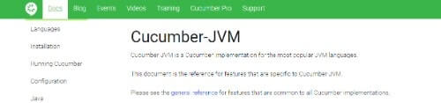

Cucumber-JVM is a Cucumber implementation for the most popular JVM languages. It consists of several modules that are downloadable from [public maven repo](https://repo1.maven.org/maven2/info/cukes/).

**Key Features:**

* It supports different JVM languages

**Cost:**

* FREE

### 5. [JD-GUI](http://jd.benow.ca/)

JD-GUI

JD-GUI is a graphical utility that exhibits Java source codes of “.class” files.

**Key Features:**

* Fast Java decompiler
* Intuitive design
* Easy navigation
* Search function and general options
* Ending note

**Cost:**

* FREE

### 6. [Hibernate](http://hibernate.org/)

[@hibernate](https://twitter.com/hibernate/)

Hibernate

Hibernate is a popular persistence API/Object relational mapping (ORM) Java tool.

**Key Features:**

* Domain model persistence for relational databases
* Full-text search for your domain model
* Annotation based constraints for your domain model
* Domain model persistence for NoSQL datastores
* Command line tools and IDE plugins for your Hibernate usages

**Cost:**

* Contact for a quote

### 7. [Javadoc](http://www.oracle.com/technetwork/java/javase/documentation/index-jsp-135444.html)

[@Oracle](https://twitter.com/Oracle)

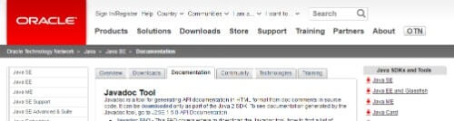

Javadoc is an API documentation-generating tool in HTML format that works through doc comments in source code. It is offered by Oracle and is free.

**Key Features:**

* Doclets API
* Taglet API
* MIF Doclet
* DocCheck Doclet
* Exclude Doclet
* Doclet Toolkit

**Cost:**

* Contact for a quote

### 8. [MySQL](https://www.mysql.com/)

[@mysql](https://twitter.com/mysql)

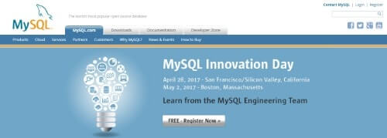

MySQL is one of the most popular open source databases. It is also supported and trusted by Oracle Corporation.

**Key Features:**

* Cross-platform support
* Update-able views
* Stored procedures, using a procedural language

**Cost:**

* Standard: $2,000
* Enterprise: $5,000
* Cluster CGE: $10,000

### 9. [Docker](https://www.docker.com/)

[@docker](https://twitter.com/docker)



Docker is a leading software container platform. It is used to eliminate “works on my machine” problems when collaborating on code with other parties.

**Key Features:**

* Package dependencies with apps in Docker containers for portability and predictability
* Works with any stack
* Better team collaboration
* Ready for production
* Extensible and flexible

**Cost:**

* Docker Community Edition (CE) – FREE
* Docker Enterprise Edition (EE)
  + Basic – Starting at $750 per node / per year
  + Standard – Starting at $1500 per node / per year
  + Advanced – Starting at $2000 per node / per year

### 10. [VMWare](https://www.vmware.com/asean.html)

[@VMware](https://twitter.com/VMware)



VMWare is a virtualization tool that allows users to partition a single physical server into multiple virtual machines.

**Key Features:**

* vSphere that features VMotion – moved running virtual machines (VMs) from one server to another
* vSphere with Operations Management
* VMware Integrated OpenStack

**Cost:**

* Free trial
* Visit the [VMware Store](http://store.vmware.com/store/vmware/en_US/home) for pricing details